**PySpark**

**Table of Contents**

**1. Introduction to Big Data 2**

**1.1. Big Data** 2

***1.1.1. Small Data vs Big Data*** *2*

***1.1.2. Big Data – Fifth V*** *2*

***1.1.3. Big Data Lifecycle*** *5*

**1.2. Common terms in Big Data** 6

***1.2.1. Instruction node (or single node capacity or node)*** *6*

***1.2.2. Cluster computing*** *6*

***1.2.3. Distributed computing vs Parallel computing (or Parallel processing)*** *7*

***1.2.4. Linear and Parallel processing*** *9*

***1.2.5. Batch and Stream processing*** *10*

***1.2.6. Real-time processing*** *12*

***1.2.7. Batch analytics and Real-time analytics*** *13*

**1.3. Data processing system for Big Data** 13

**1.4. Apache Hadoop** 15

***1.4.1. Hadoop ecosystem*** *16*

***1.4.2. Hadoop Distributed File System - HDFS*** *17*

***1.4.3. MapReduce*** *20*

**1.5. Apache Spark (overview)** 22

***1.5.1. Why use Spark?*** *23*

***1.5.2. Spark and HDFS:*** *23*

***1.5.3. Spark and MapReduce:*** *24*

***1.5.4. Spark and YARN:*** *24*

***1.5.5. Spark don NOT replace Hadoop:*** *24*

***1.5.6. Spark Features*** *25*

***1.5.7. Spark Ecosystem*** *27*

**2. Apache Spark** 27

***2.1. Spark core*** *27*

***2.2. Spark SQL*** *28*

***2.3. Spark Streaming*** *29*

***2.4. MLlib*** *31*

***2.5. GraphX*** *31*

***2.6. Cluster Manager*** *32*

***2.7. SparkContext*** *32*

***2.8. SparkSession*** *34*

# **1. Introduction to Big Data**

## **1.1. Big Data**

### **1.1.1. Small Data vs Big Data**

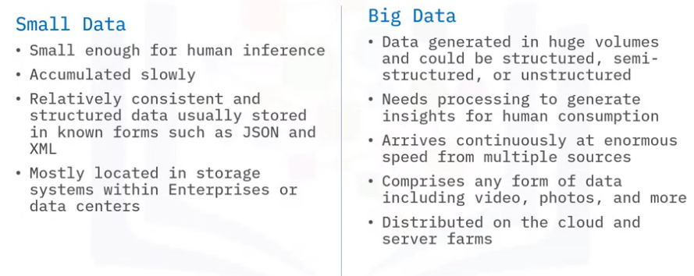

### **1.1.2. Big Data – Fifth V**

#### **Velocity**

***Velocity*** is the speed at which data arrives.

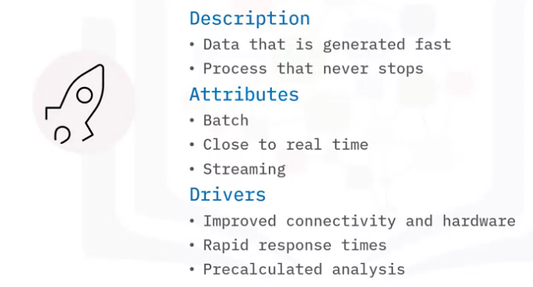

#### **Volume**

***Volume*** is the increase in the amount of data stored over time.

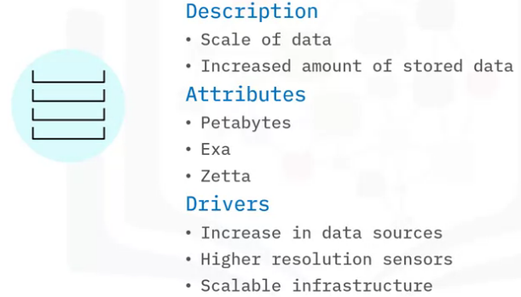

#### **Variety**

***Variety*** is the diversity of data. Many forms of data exist and need to be stored.

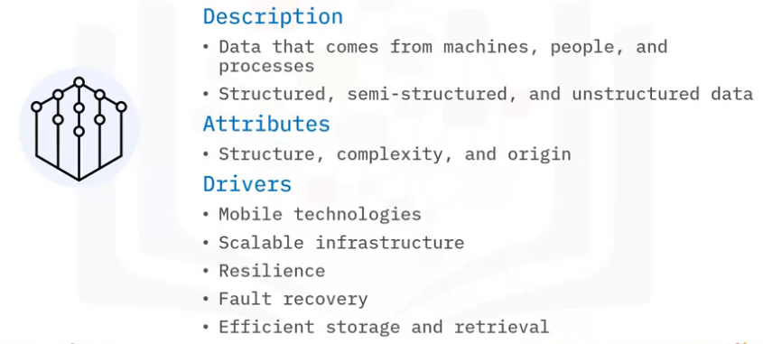

#### **Veracity**

***Veracity*** is the certainty of data.

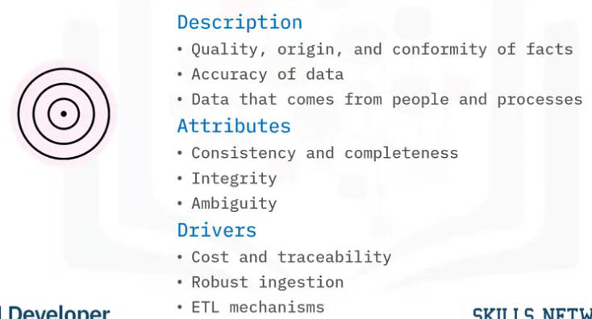

#### **Value**

***Value:*** produce value in the form of faster and smarter business decisions, increase efficient use of resources, and discover of new market opportunities.

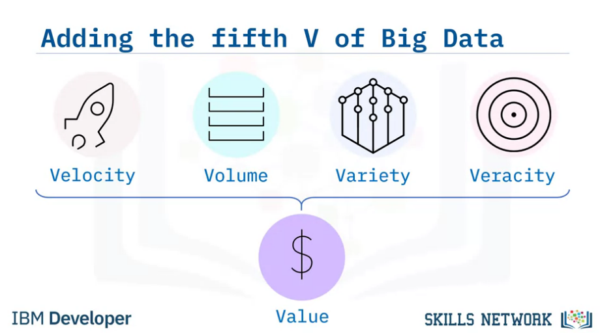

### **1.1.3. Big Data Lifecycle**

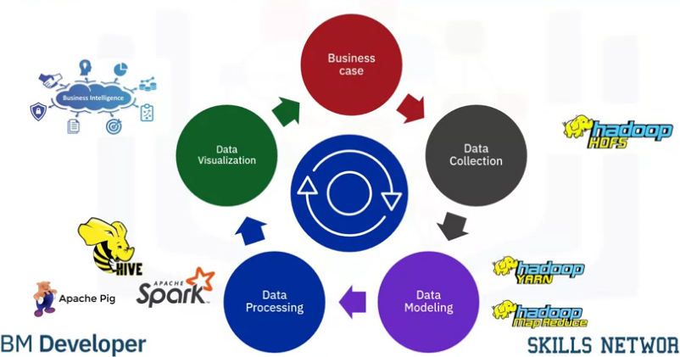

#### **Business case:**

***Big Data*** collection is initiated as a result of a business problem or requirement.

#### **Data Collection:**

As data is collected, it gets stored using a framework for distributed storage such as ***Hadoop HDFS.***

#### **Data Modeling:**

To make sense of all the data collected, ***Map*** and ***Reduce*** tasks and scripts create a data model **to store it in a database.** This ***data model*** includes the various data entities (or objects), and the relationship and rules between these entities.

#### **Data Processing:**

After modeling, data is ready to be processed. Tools such as ***Apache Spark*** or ***Apache Hadoop*** are used to produce meaningful information from the modeled data.

#### **Data Visualization:**

Finally, the processed data is visualized and presented in a graphical format such as charts and graphs. This visualized data is then used for making meaningful business decisions and lead to new business cases, thereby creating a continuous life cycle.

## **1.2. Common terms in Big Data**

### **1.2.1. Instruction node (or single node capacity or node)**

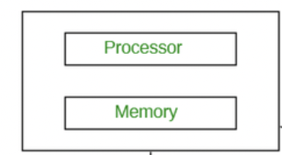

Or

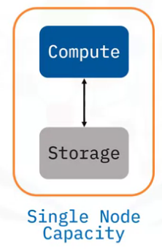

### **1.2.2. Cluster computing**

***Cluster computing*** is a collection of tightly or loosely connected computers that work together so that they act as a single entity. The connected computers execute operations all together thus creating the idea of a single system. The clusters are generally connected through fast local area networks (LANs).

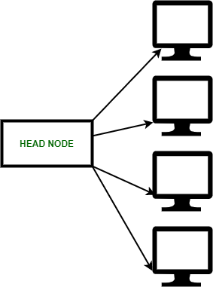

***Why cluster computing is important:***

* ***Cluster computing*** gives a relatively inexpensive, unconventional to the large server or mainframe computer solutions.
* It resolves the demand for content criticality and process services in a faster way. Many organizations and IT companies are implementing cluster computing to augment their scalability, availability, processing speed and resource management at economic prices.
* **It ensures that computational power is always available.**
* **It provides a single general strategy for the implementation and application of parallel high-performance systems independent** of certain hardware vendors and their product decisions.

### **1.2.3. Distributed computing vs Parallel computing (or Parallel processing)**

***Distributed computing:***

***Distributed computing*** is defined as a type of computing where multiple computer systems work on a single problem. Here all the computer systems are linked together and the problem is divided into sub-problems where each part is solved by different computer systems.

**The goal of distributed computing is to increase the performance and efficiency of the system and ensure fault tolerance**.

In the below diagram, each processor has its own local memory and all the processors communicate with each other over a network.

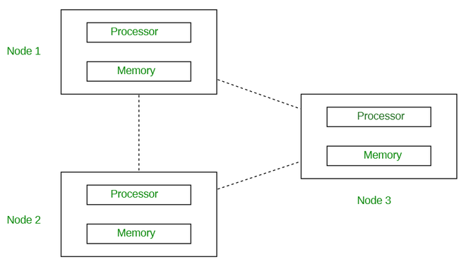

***Parallel computing:***

***Parallel computing*** is defined as a type of computing where multiple computer systems are used simultaneously. Here a problem is broken into sub-problems and then further broken down into instructions. These instructions from each sub-problem are executed concurrently on different processors.

**The goal of parallel computing is to save time and provide concurrency.**

Here in the below diagram you can see how the parallel computing system consists of multiple processors that communicate with each other and perform multiple tasks over a shared memory simultaneously.

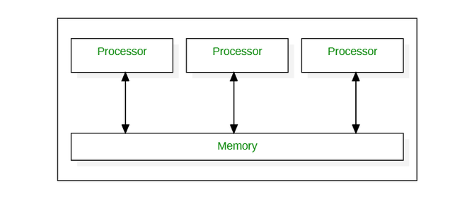

***Different between Distributed computing and Parallel computing:***

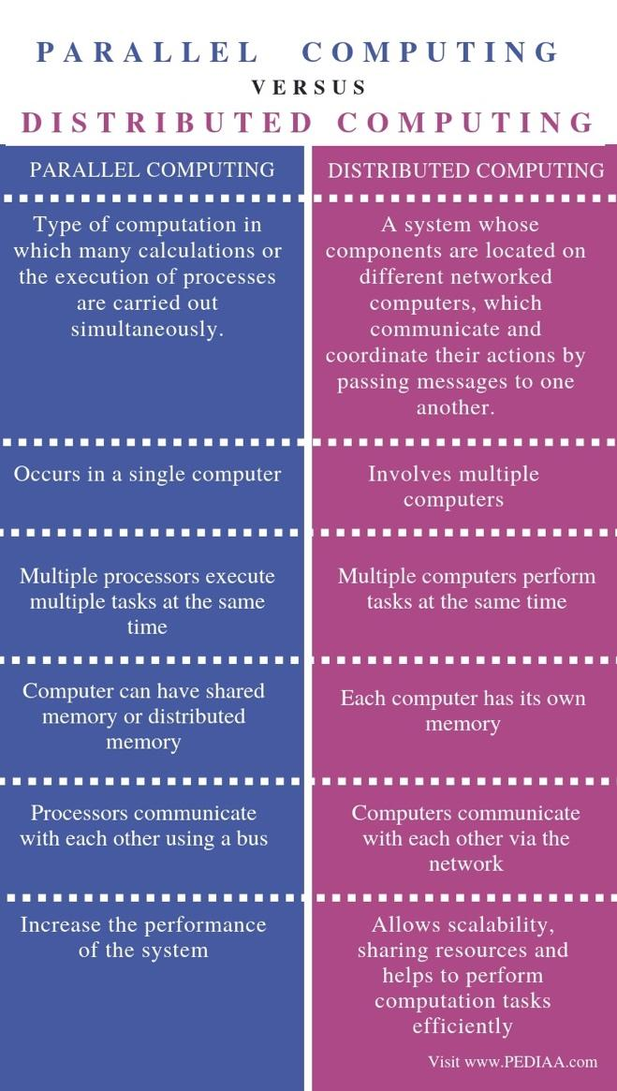

### **1.2.4. Linear and Parallel processing**

***Linear processing:***

If an error occurs in any one of the instructions, the entire sequence of instructions is executed from the beginning after the error has been resolved. → It is evident from the processing method that ***Linear processing*** is best suited for minor computing tasks and **is inefficient and time consuming when it comes to processing complex problems such as Big Data.**

***Parallel processing:***

The instructions are then distributed to multiple execution nodes of equal processing power and are executed in parallel. **Since the instructions are run on separate execution nodes, errors can be fixed and executed locally independent of other instructions**.

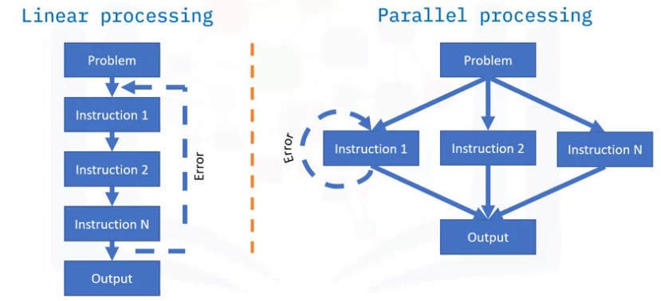

***Parallel processing advantages:***

* ***Parallel processing*** approach can process large dataset in fraction of time.
* Less memory and compute requirements need cause set of instructions are distributed to smaller execution nodes.
* More executed nodes can be added or removed from processing network depending on complexity of the problem.

### **1.2.5. Batch and Stream processing**

***Batch processing:***

***Batch processing*** refers to processing of high volume of data in batch within a specific time span. It processes large volume of data all at once. ***Batch processing*** is used when data size is known and finite. It takes little longer time to processes data. It requires dedicated staffs to handle issues. Batch processor processes data in multiple passes. **When data is collected overtime and similar data batched/grouped together then in that case batch processing is used.**

*Challenges with* ***Batch Processing:***

* Debugging of these system is difficult as it requires dedicated professional to fix the error.
* Software and training requires high expenses initially just to understand batch scheduling, triggering, notification etc.

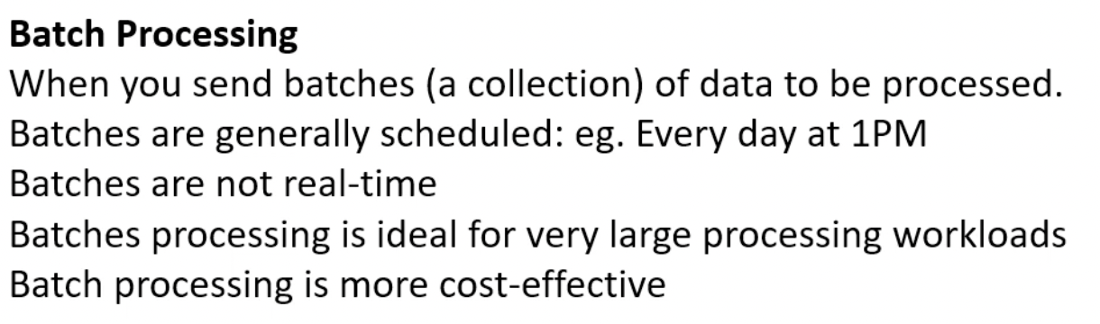

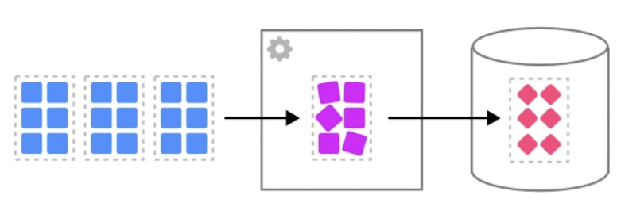

***Stream processing:***

***Stream processing*** refers to processing of continuous stream of data immediately as it is produced. It analyzes streaming data in real time. ***Stream processing*** is used when the data size is unknown and infinite and continuous. It takes few seconds or milliseconds to process data. In stream processing data output rate is as fast as data input rate. Stream processor processes data in few passes. **When data stream is continuous and requires immediate response then in that case stream processing is used.**

*Challenges with* ***Stream Processing:***

* Data input rate and output rate sometimes creates a problem.
* Cope with huge amount of data and immediate response.

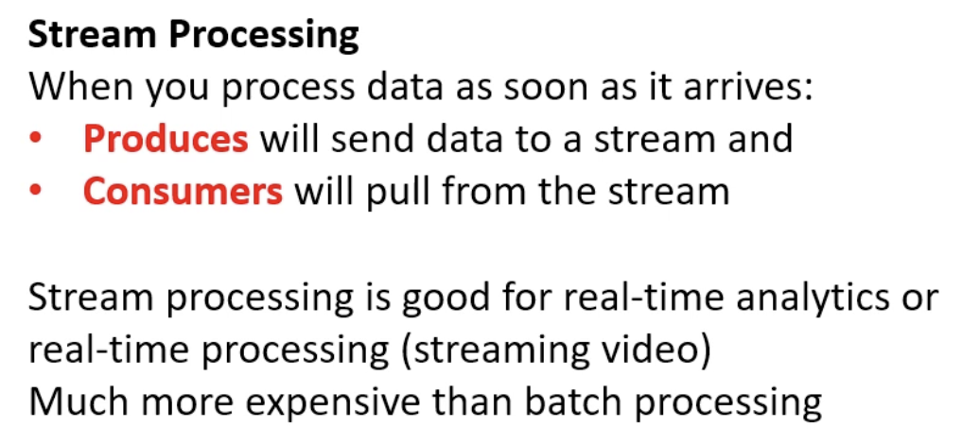

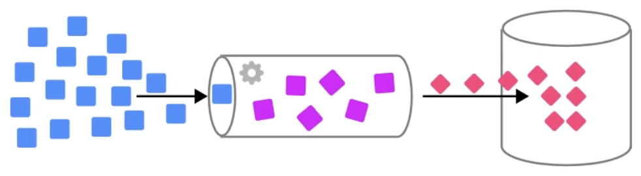

***Different between Batch processing and Stream processing:***

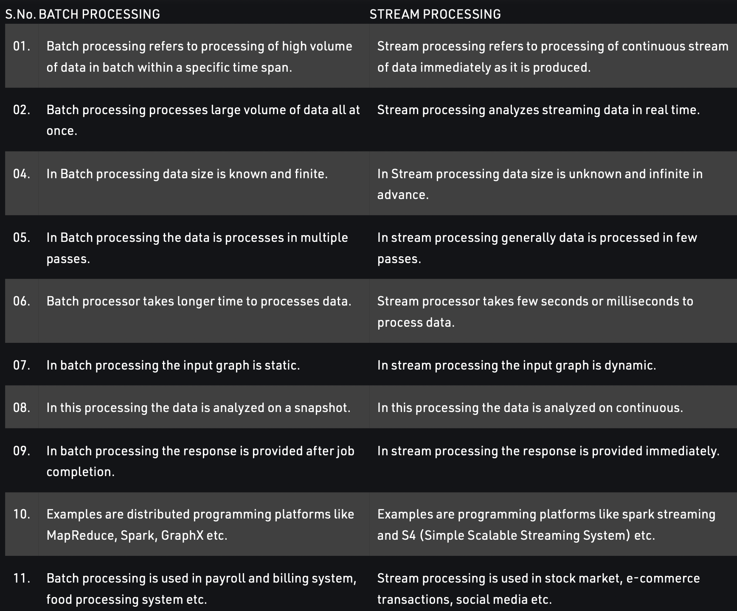

### **1.2.6. Real-time processing**

***Real time processing*** deals with streams of data that are captured in real-time and processed with minimal latency to generate real-time (or near-real-time) reports or automated responses. For example, a real-time traffic monitoring solution might use sensor data to detect high traffic volumes. This data could be used to dynamically update a map to show congestion, or automatically initiate high-occupancy lanes or other traffic management systems.

***Real-time processing compare with Batch / Stream processing:***

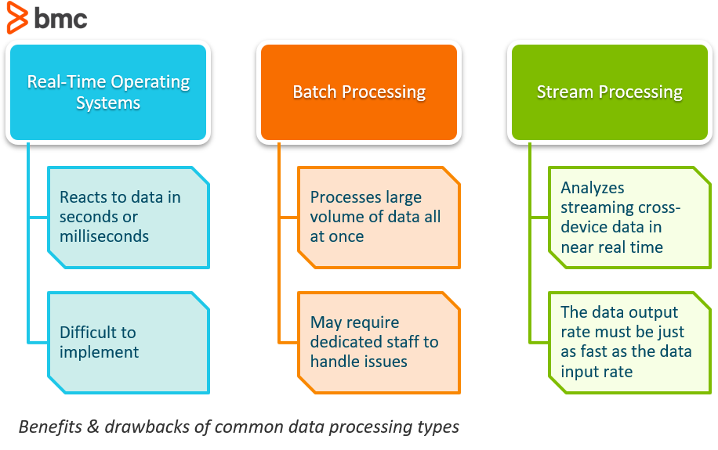

### **1.2.7. Batch analytics and Real-time analytics**

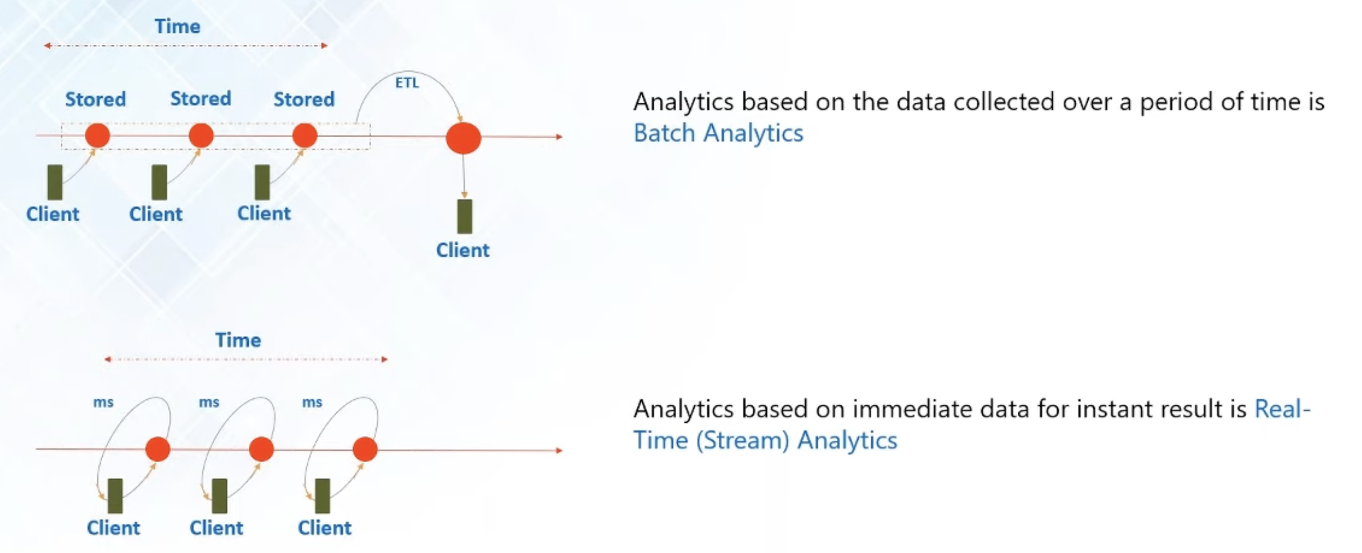

## **1.3. Data processing system for Big Data**

Two Big Data frameworks:

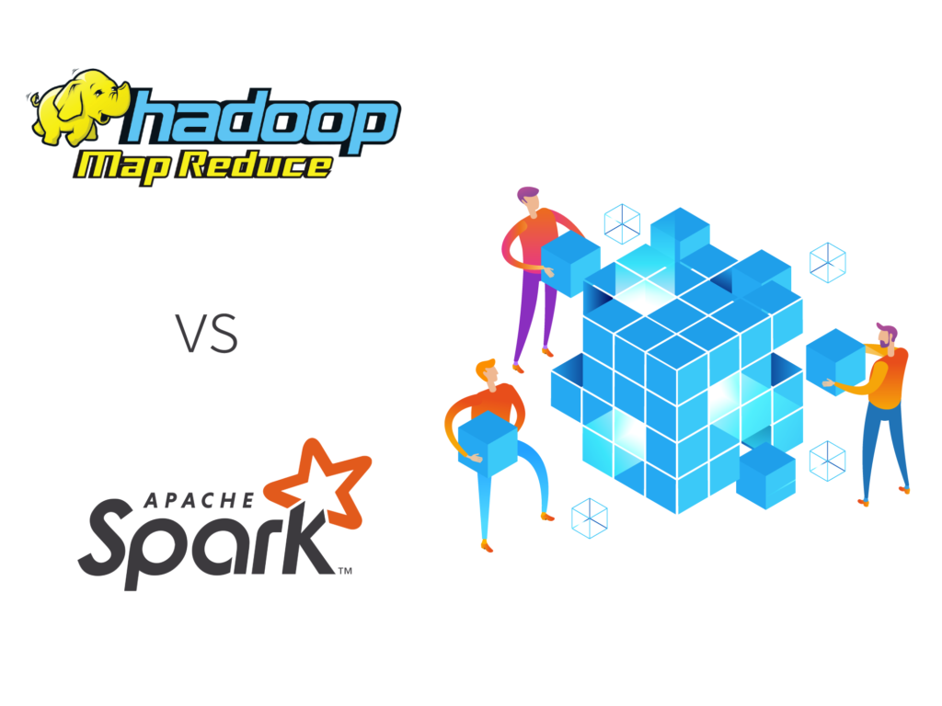

***Hadoop MapReduce:*** Scalable & fault tolerant framework is coded by Java

* Open source.
* Batch Processing.

***Apache Spark:*** Lightning-fast cluster computing system

* Open source.
* Batch processing & Real-time processing

***Batch Processing in Hadoop:***

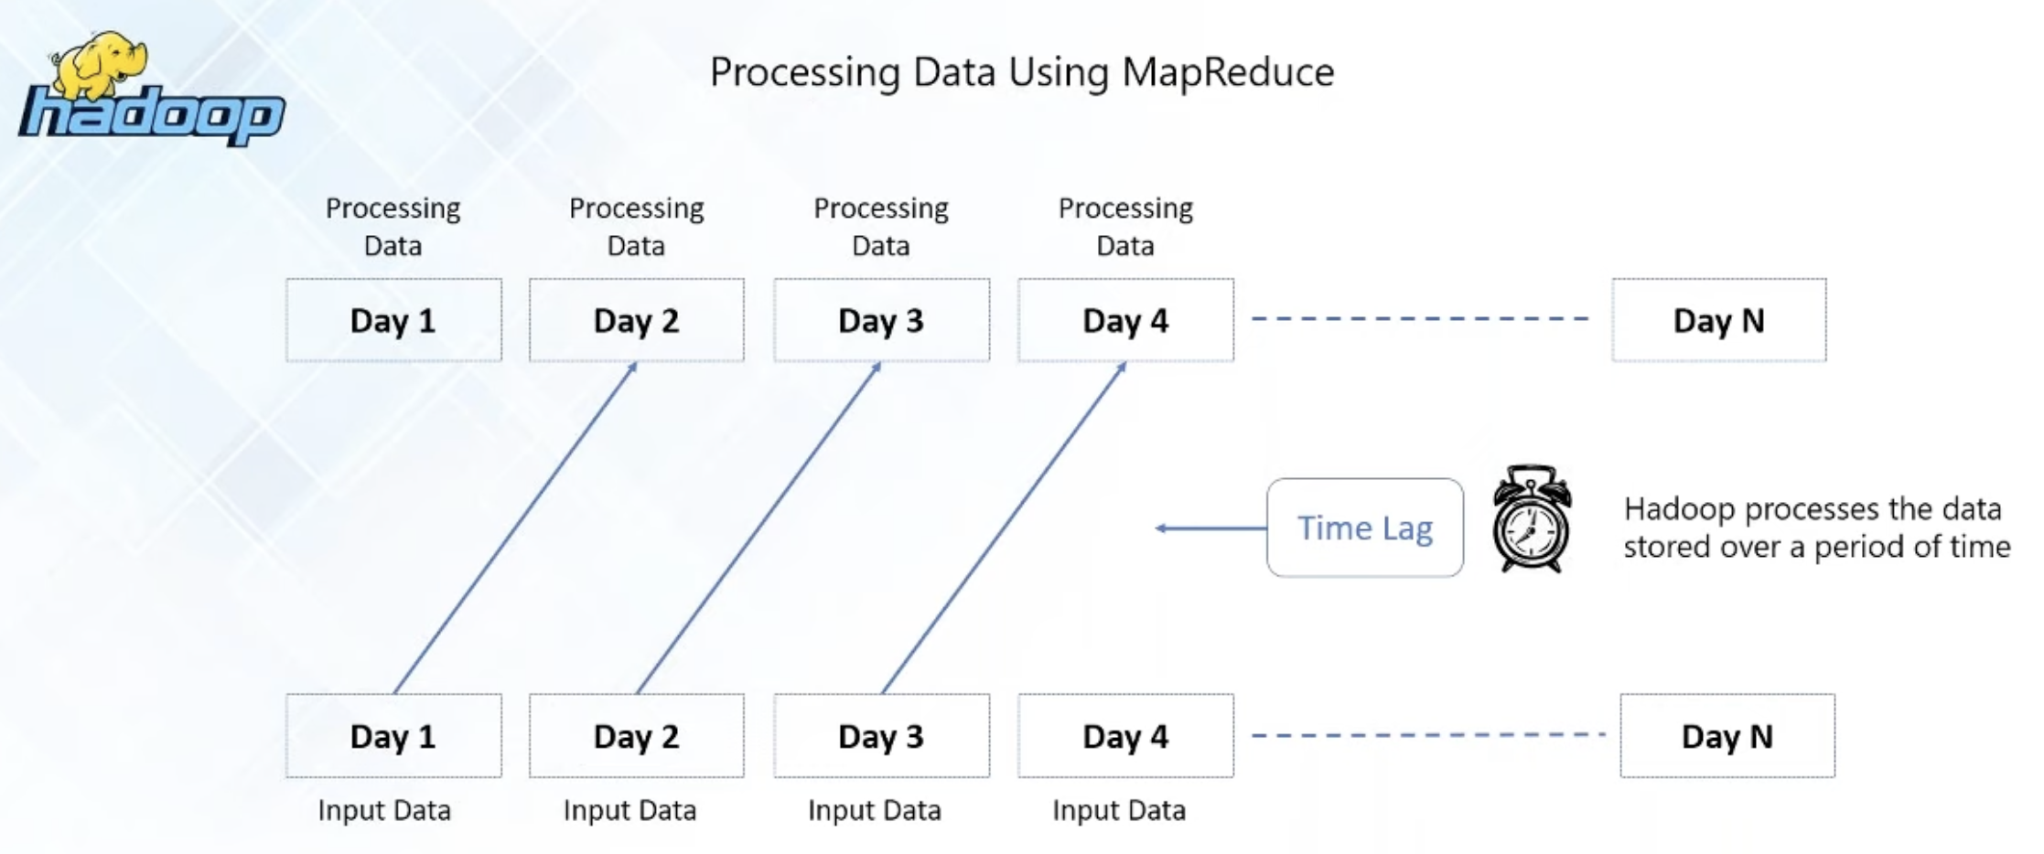

***Real-time Processing in Spark:***

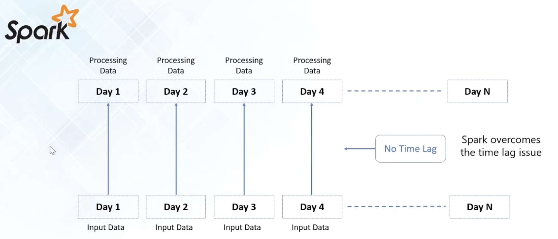

***Spark vs Haddop***

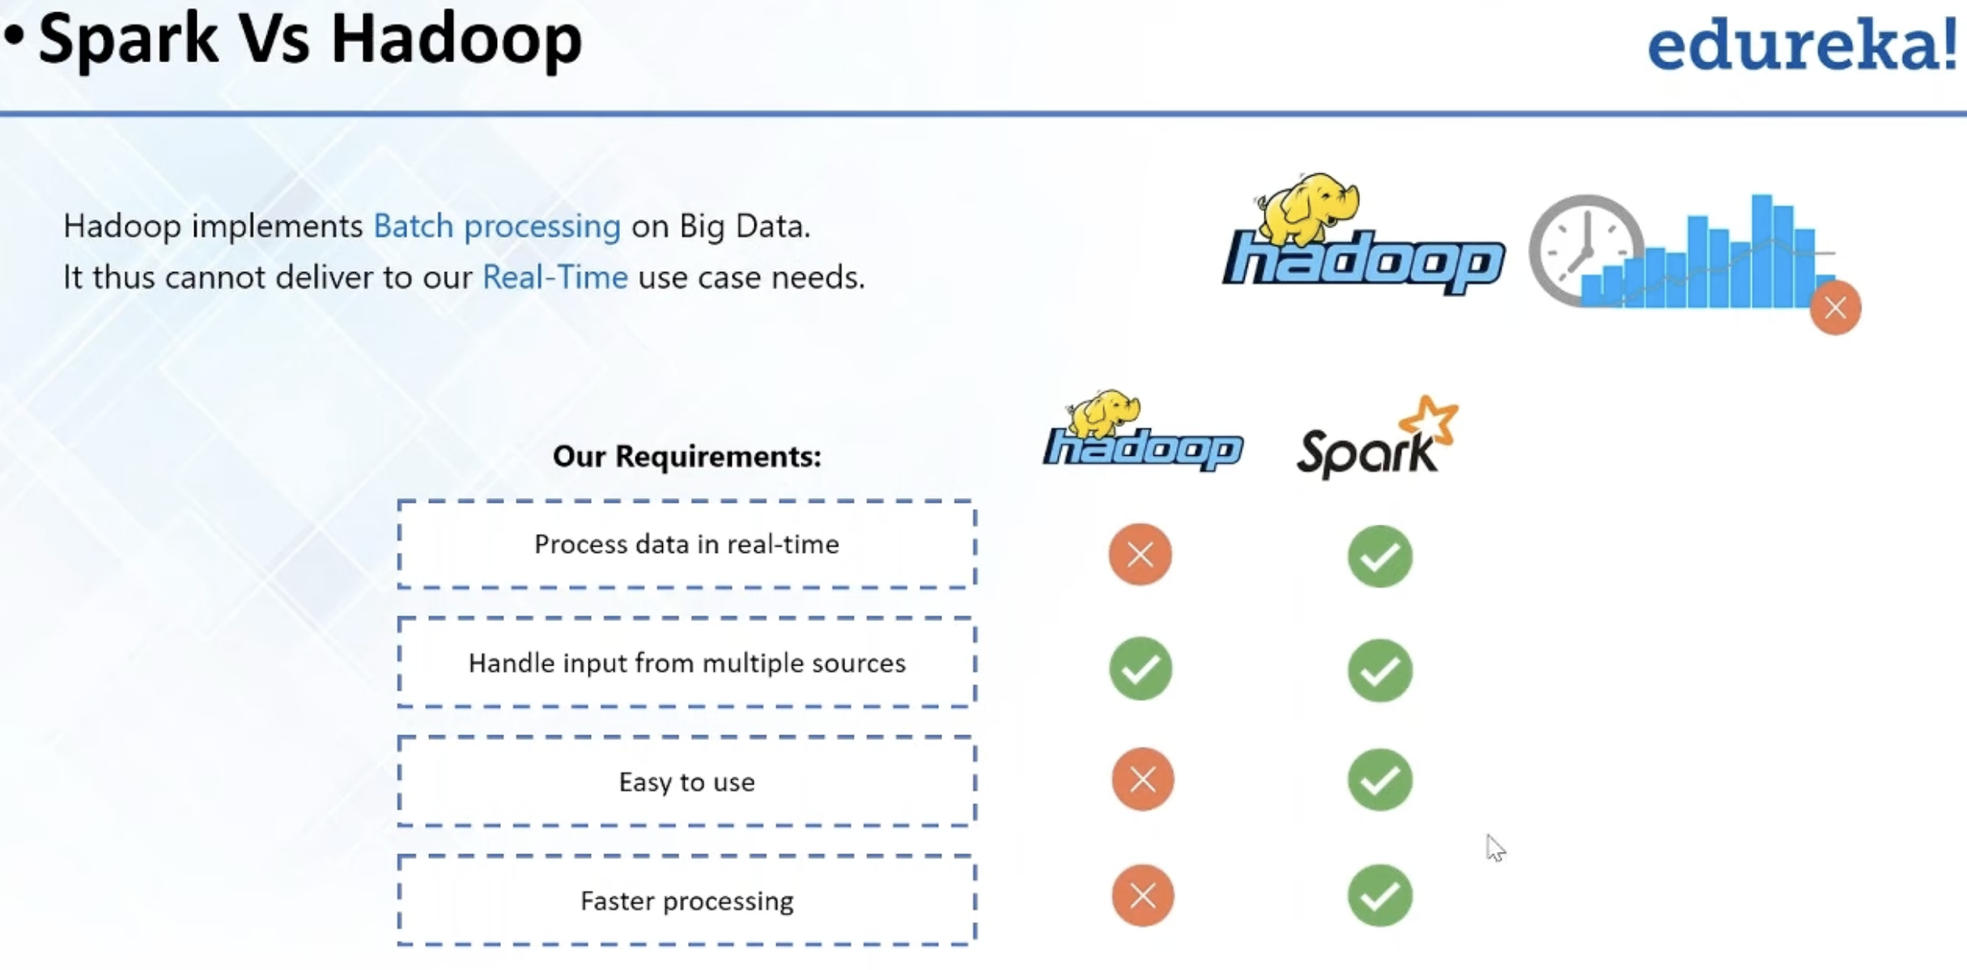

*Note:* ***Spark*** is not intended to replace ***Hadoop.*** (Discuss it later).

## **1.4. Apache Hadoop**

***Hadoop*** is a framework that allow us to store and process large datasets in parallel and distributed fashion.

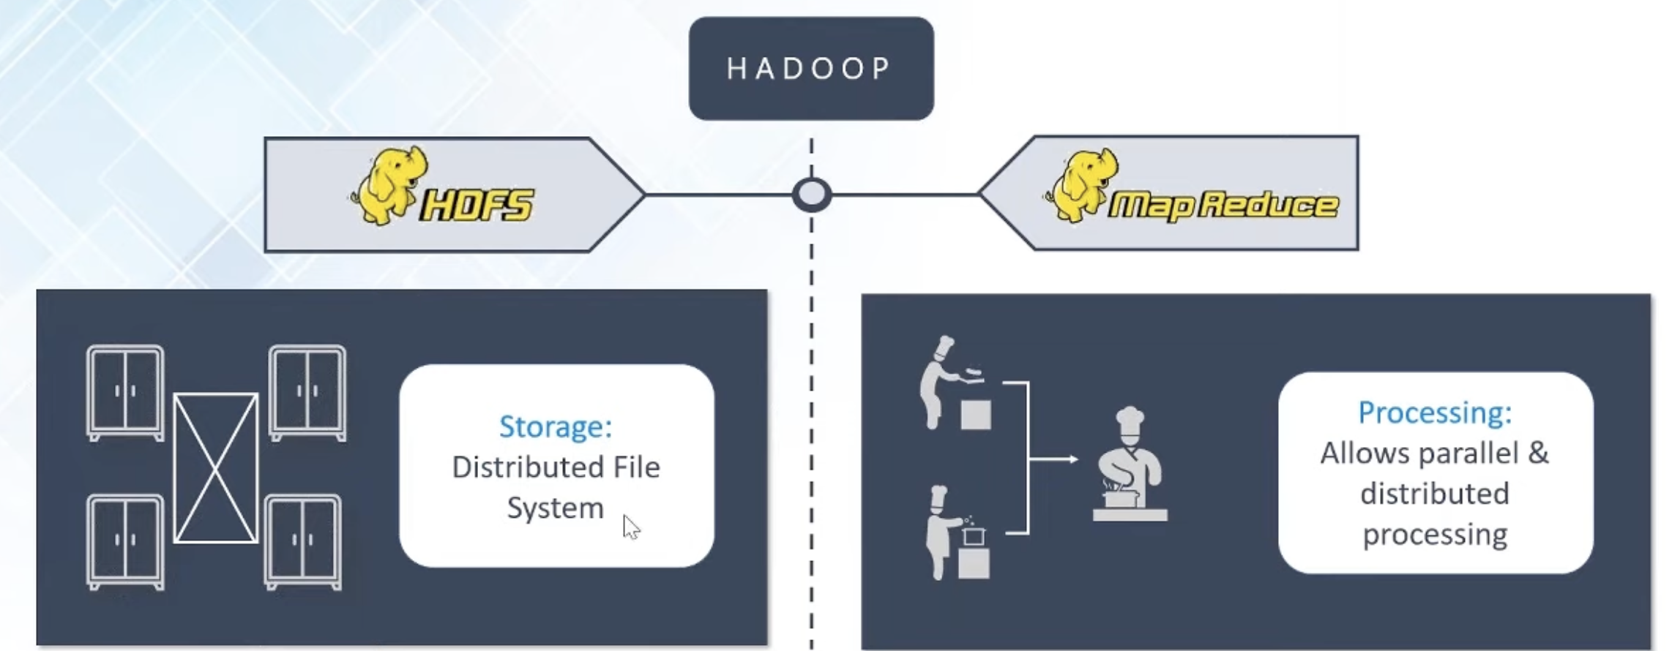

### **1.4.1. Hadoop ecosystem**

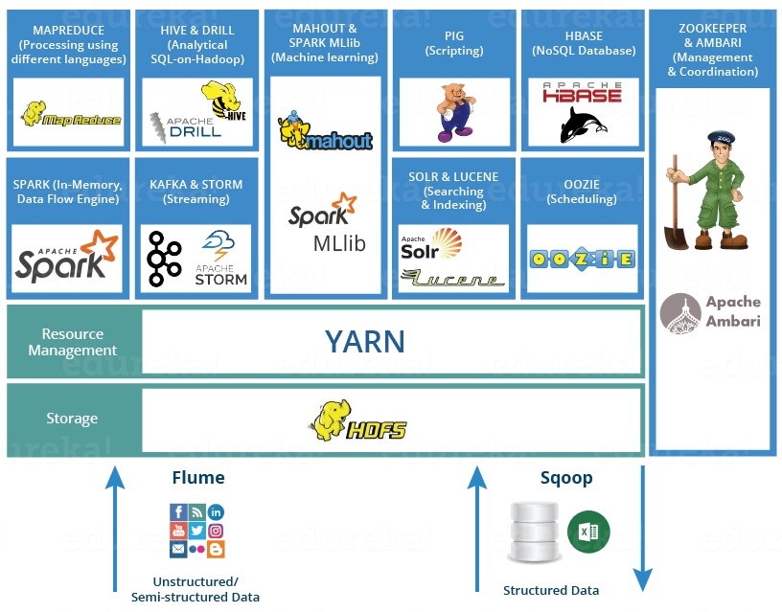

***Main component of Apache Hadoop:***

* ***Hadoop Distributed File System (HDFS):*** is bottom layer component for storage. HDSF shares files to separated blocks and distribute it into nodes of cluster.
* ***Yet Another Resource Negotiator (YARN):*** cluster resource manager that schedules task and allocates resources (e.g., CPU and memory) to applications.
* ***MapReduce:*** splits big data processing tasks into smaller ones, distributes the small tasks across different nodes, then runs each task***.***
* ***Hadoop Common (Hadoop Core):*** set of common libraries and utilities that the other three modules depend on.

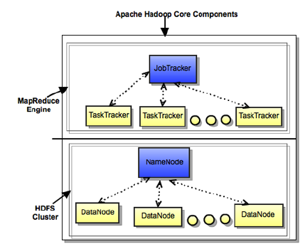

### **1.4.2. Hadoop Distributed File System - HDFS**

**HDFS**is a distributed file system that handles large data sets running on commodity hardware.

***The goals of HDFS:***

* ***Fast recovery from hardware failures***

Because one ***HDFS*** instance may consist of thousands of servers, failure of at least one server is inevitable. ***HDFS*** has been built to detect faults and automatically recover quickly.

* ***Access to streaming data***

***HDFS*** is intended more for batch processing versus interactive use, so the emphasis in the design is for high data throughput rates, which accommodate streaming access to data sets.

* ***Accommodation of large data sets (nơi lưu trữ các dữ liệu lớn)***

***HDFS*** accommodates applications that have data sets typically gigabytes to terabytes in size. ***HDFS*** provides high aggregate data bandwidth and can scale to hundreds of nodes in a single cluster.

* ***Portability***

To facilitate adoption, ***HDFS*** is designed to be portable across multiple hardware platforms and to be compatible with a variety of underlying operating systems.

***HDFS core components:***

* NameNode
* DataNode
* Secondary NameNode

***HDFS core components – NameNode and DataNode:***

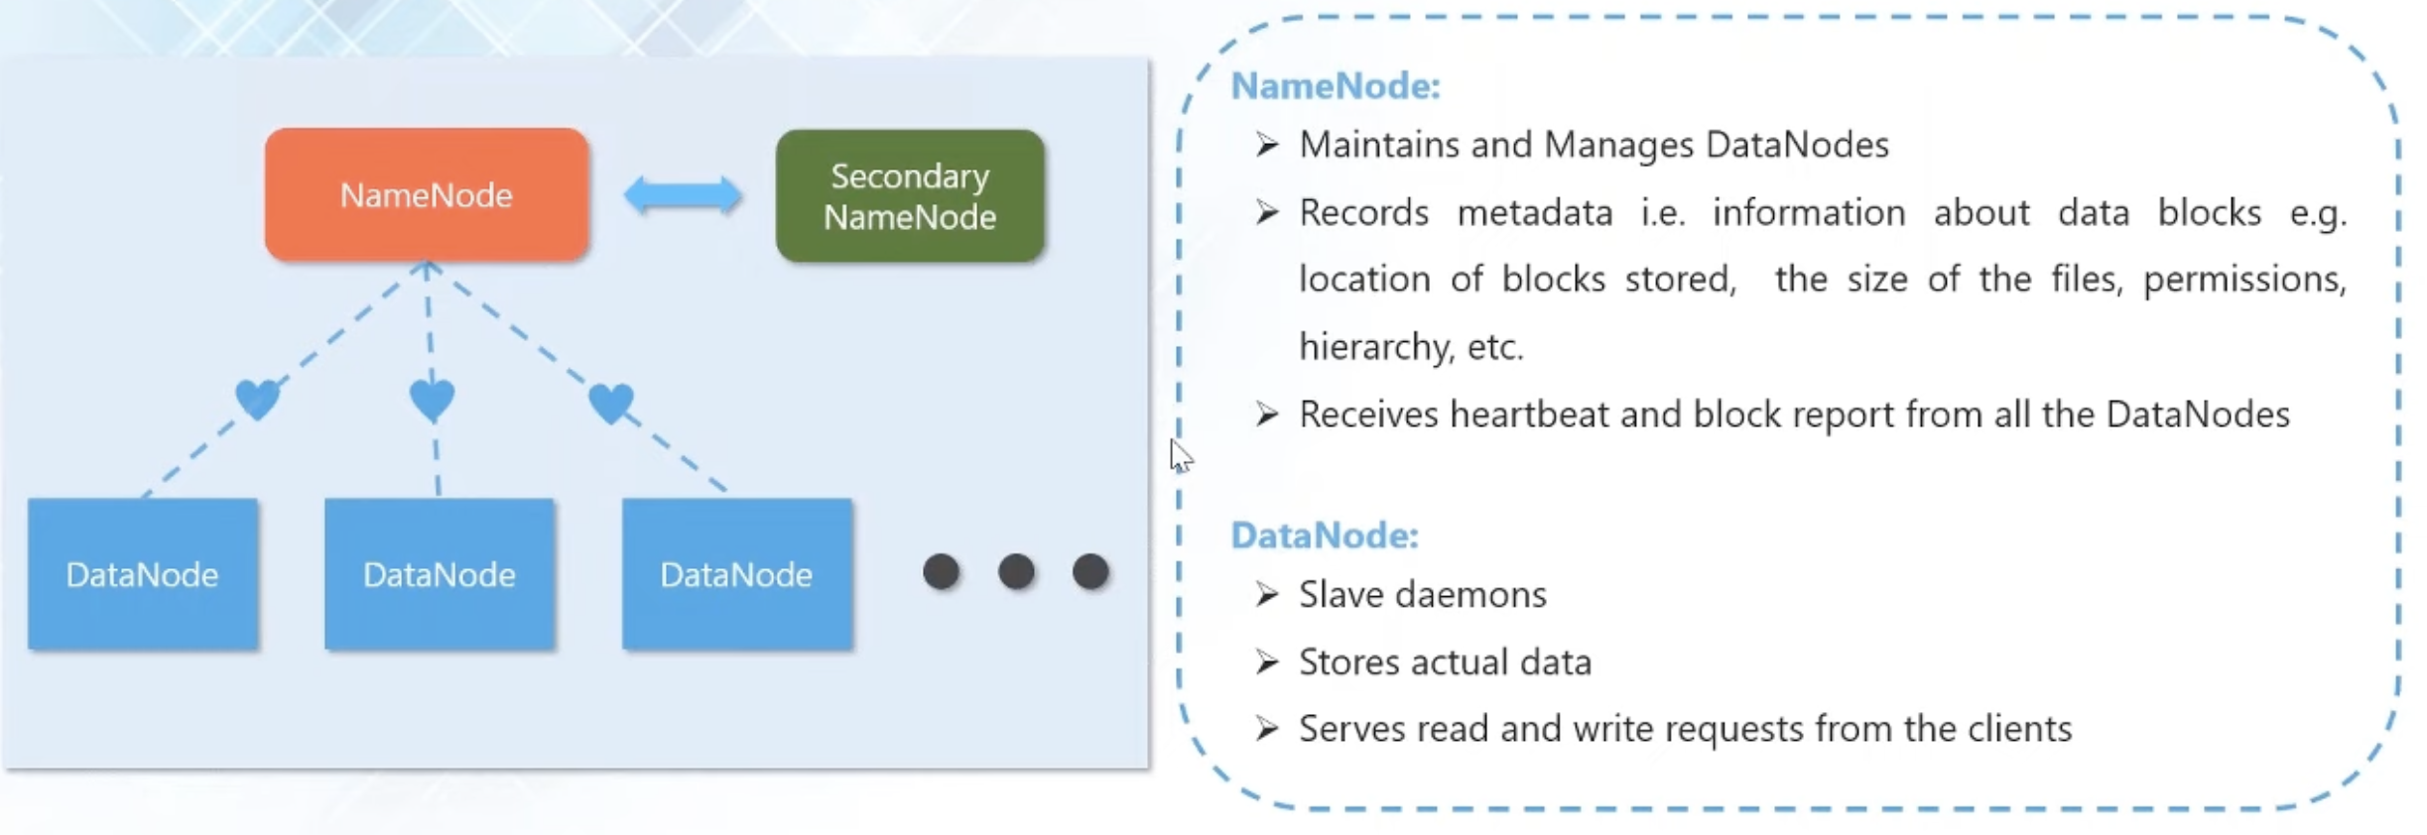



***HDFS core components – Secondary NameNode:***

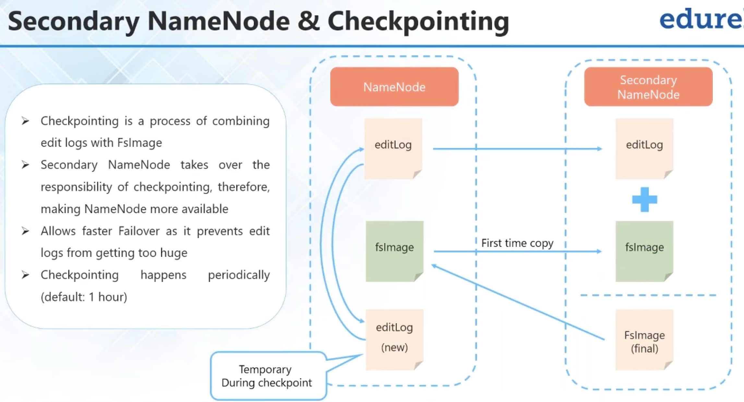

***HDFS Data Blocks:***

Each file is stored on HDFS as blocks.

The default size of each block is 128 MB in Apache Hadoop 2.x.

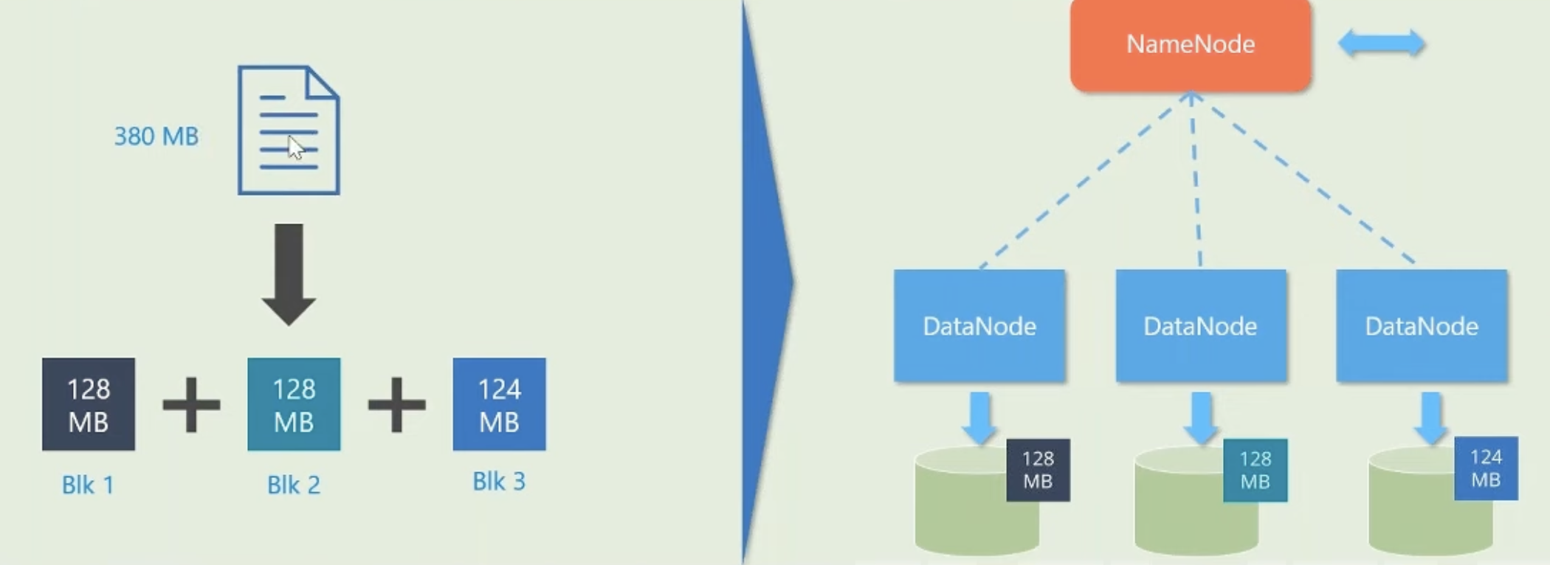

If one ***DataNode*** crashed containing the data block 🡪 each data block is replicated (thrice default mean default 3 other blocks) and are distributed across ***DataNode.***

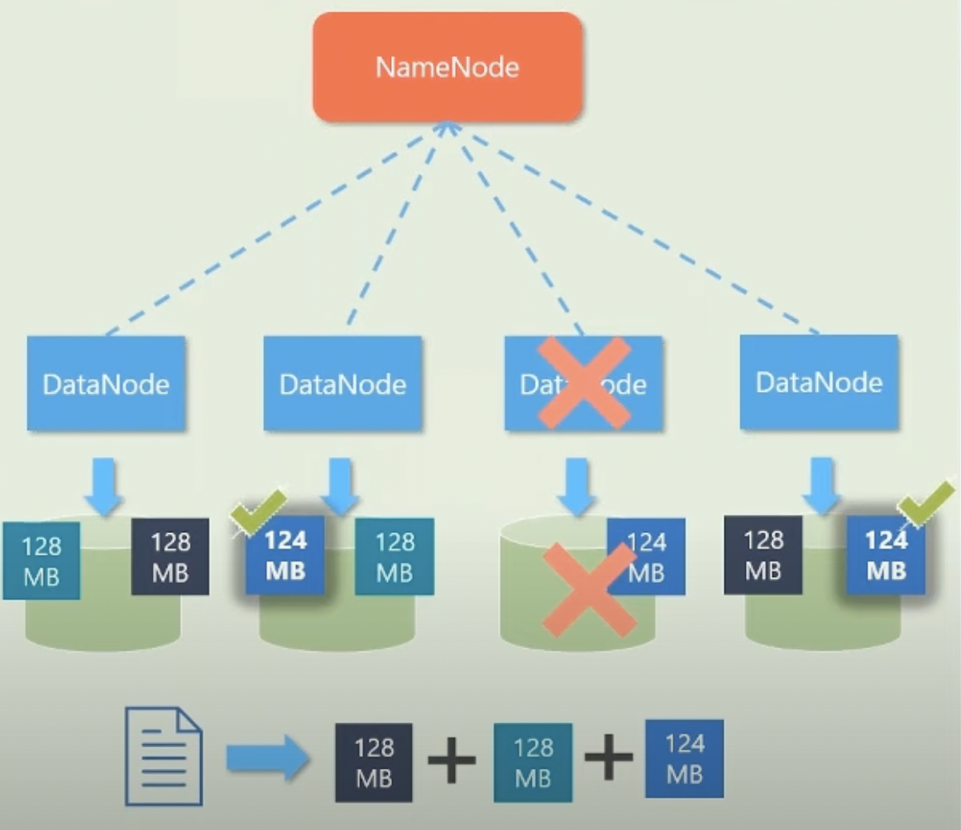

### **1.4.3. MapReduce**

***MapReduce*** is a programming framework that allows us to perform ***distributed*** and ***parallel*** ***processing*** on large datasets in distributed environment.

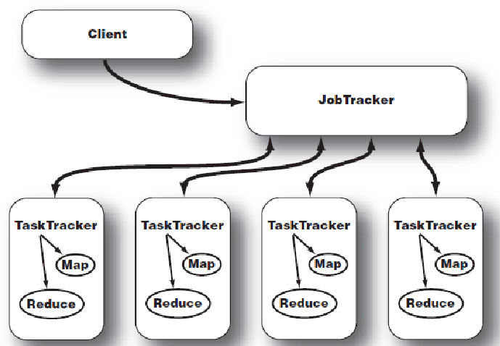

***MapReduce core components:***

* ***JobTracker:*** sends codes to execute on ***TaskTrackers.***
* ***TaskTracker:*** tracks and perform ***Map*** and ***Reduce*** tasks.

***Inside TaskTracker – MapReduce work:***

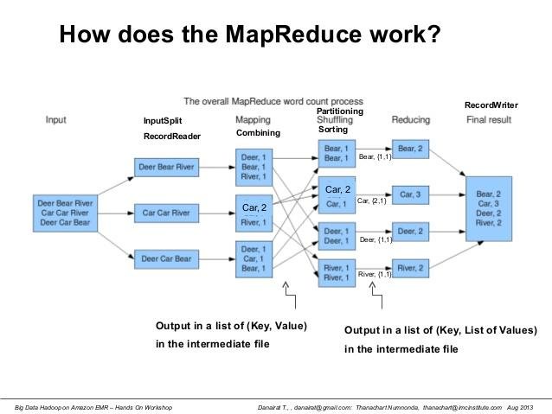

***MapReduce Layer and HDFS Layer:***

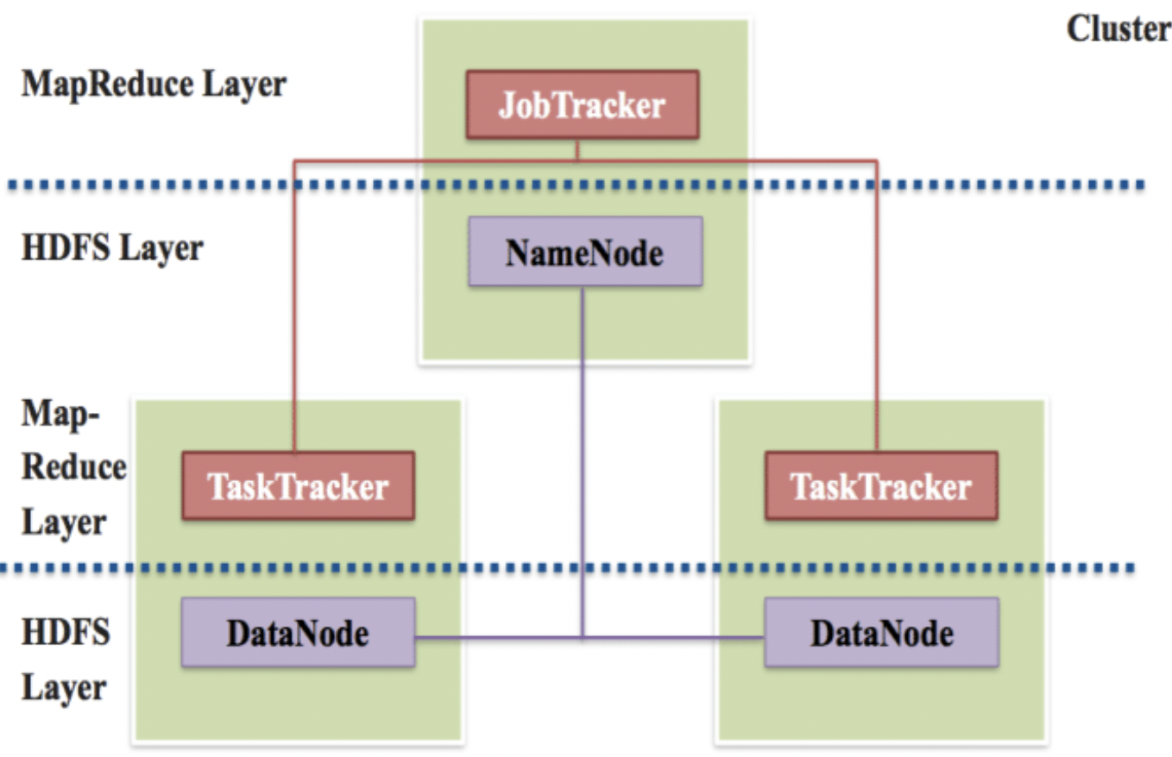

## **1.5. Apache Spark (overview)**

***Apache Spark*** is an open-source cluster-computing framework for ***real-time processing*** developed by the Apache Software Foundation.

***Apache Spark*** provide interface for programming entire clusters with implicit ***data parallelism*** and ***fault-tolerance.***

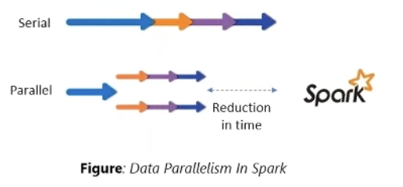

***Apache Spark*** was built on top of ***Hadoop MapReduce*** and **it extends the *MapReduce* model to efficiently use more types of computations.**

### **1.5.1. Why use Spark?**

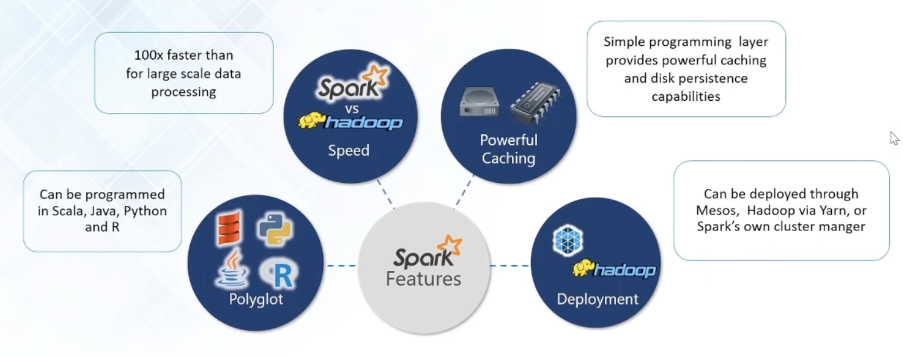

### **1.5.2. Spark and HDFS:**

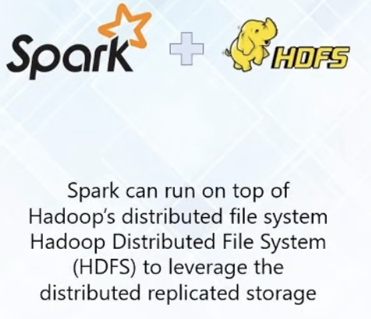

### **1.5.3. Spark and MapReduce:**

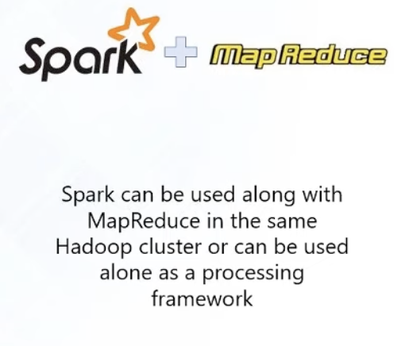

### **1.5.4. Spark and YARN:**

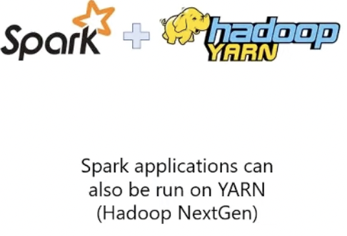

### **1.5.5. Spark don NOT replace Hadoop:**

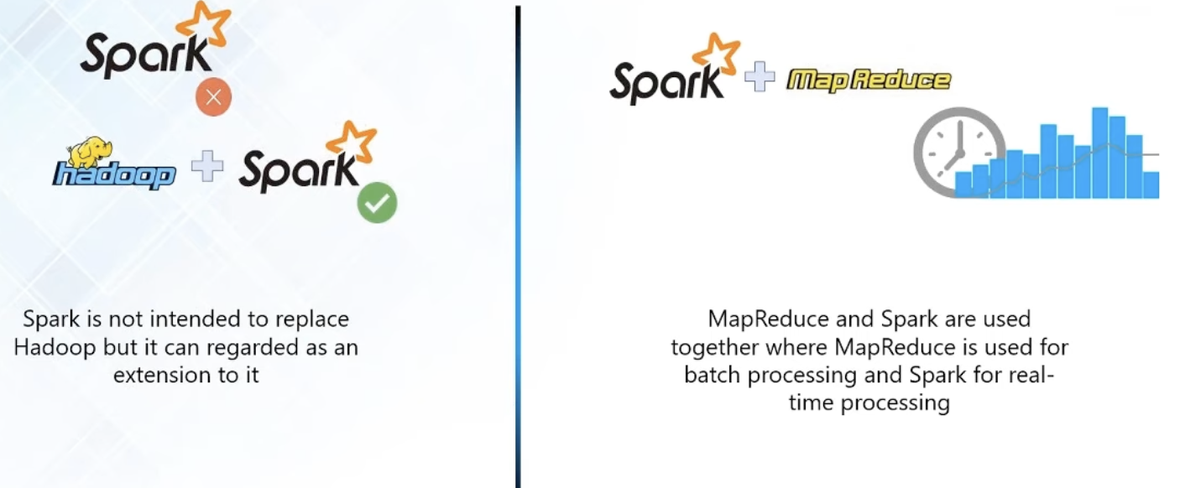

### **1.5.6. Spark Features**

***Speed:***

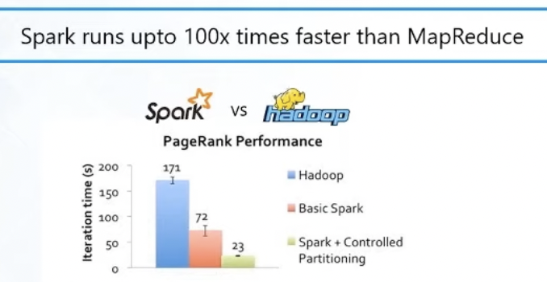

***Variety:***

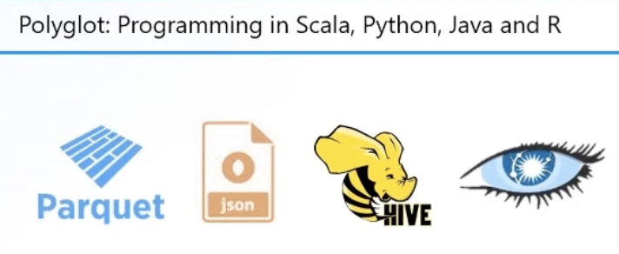

***Lazy Evaluation:***

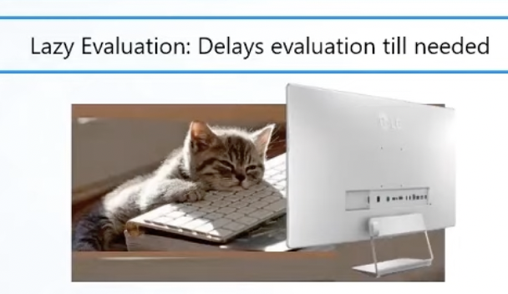

***In-Memory Computation:***

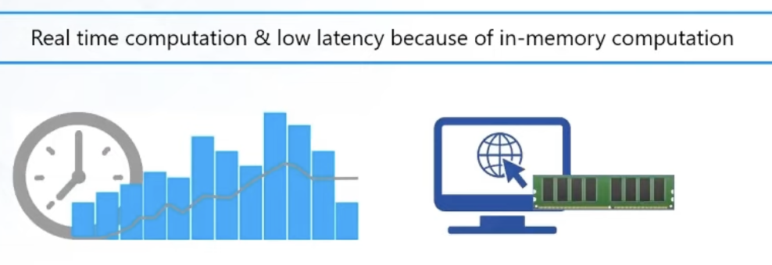

***Hadoop Integration:***



***Machine Learning support:***

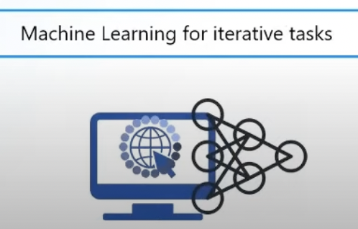

### **1.5.7. Spark Ecosystem**

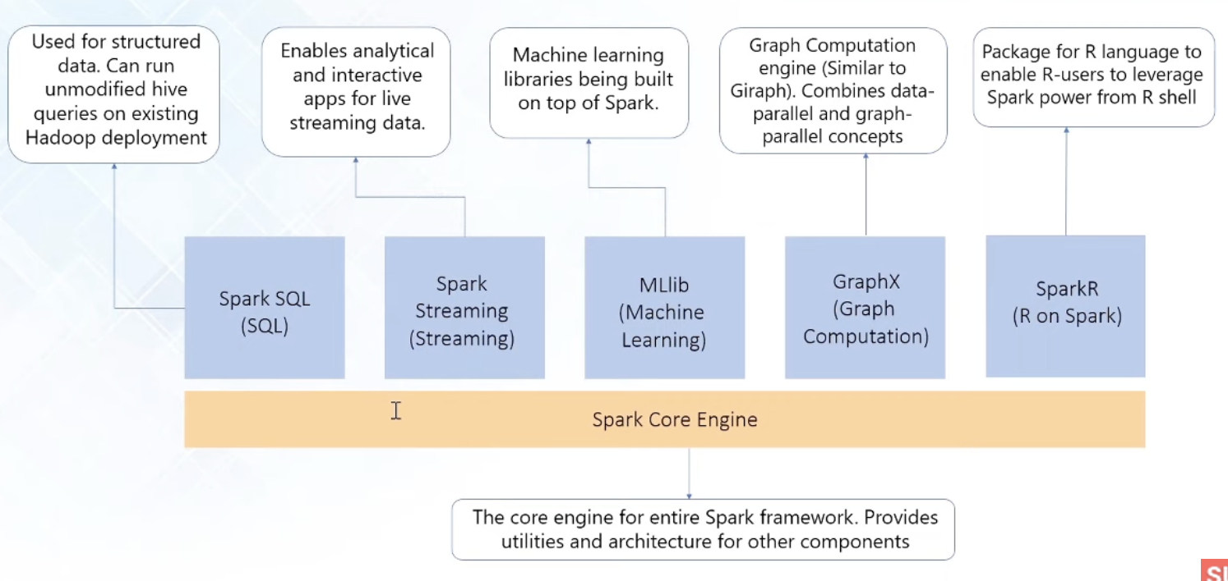

### **1.5.8. Apache Spark – Compare with MapReduce**

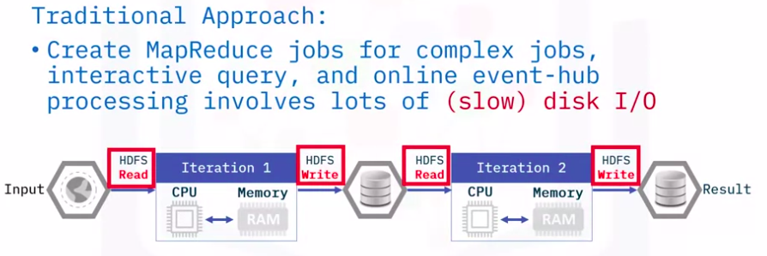

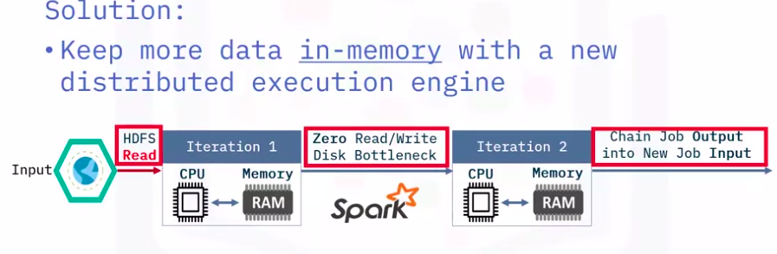

### **1.5.9. Apache Spark – Role in Big Data**

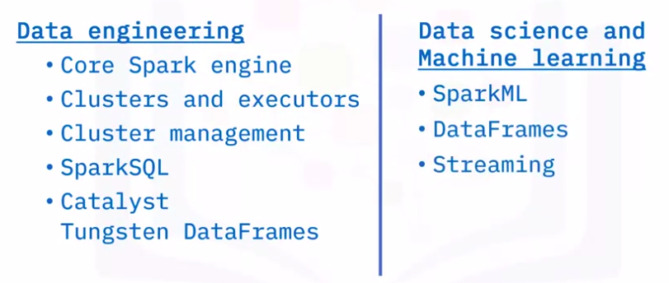

## **2. Apache Spark**

**Apache Spark Components:**

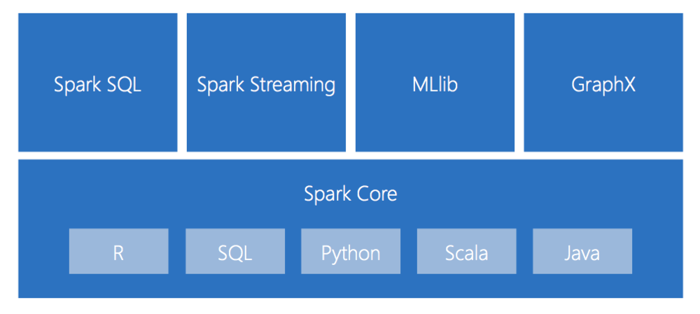

### **2.1. Spark core**

***Spark core*** is the base engine for large-scale parallel and distributed data processing.

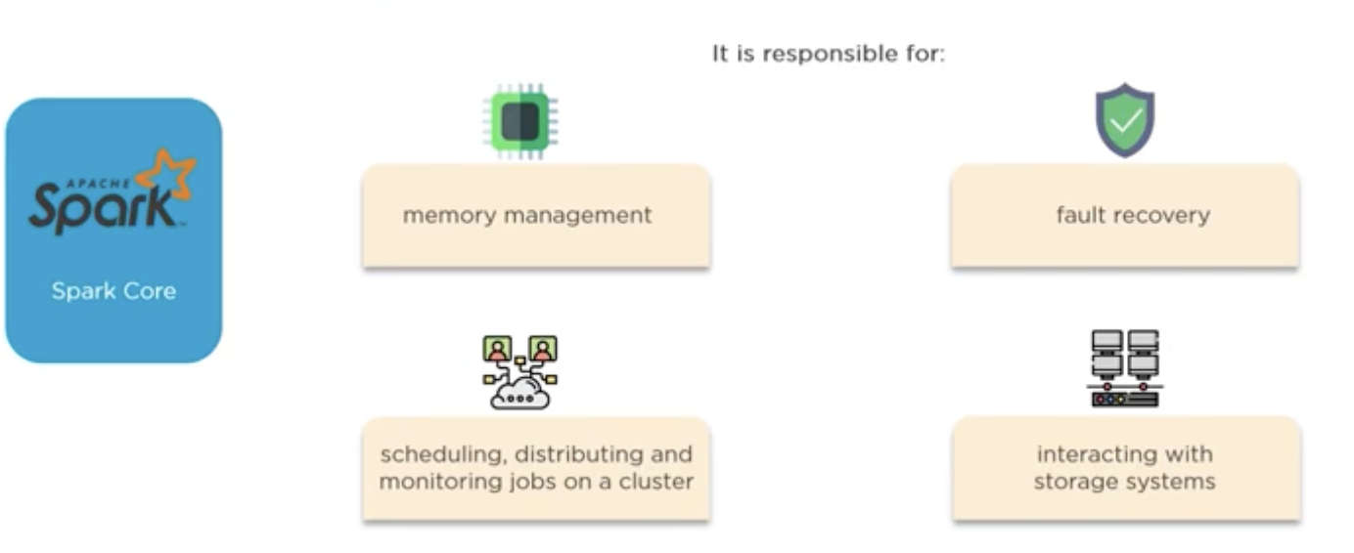

***Spark core*** is embedded with ***RDDs*** (*Resilient Distributed Dataset – Bộ dữ liệu phân tán đàn hồi*). ***RDD*** is an immutable fault-tolerance, distributed collection of objects that can be operated on in parallel.

Two main operations in ***RDD***:

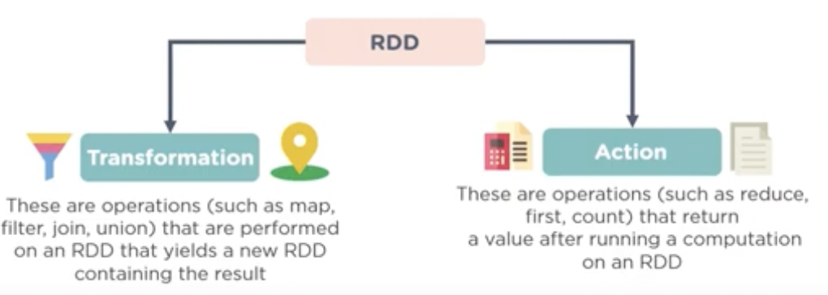

*We will discuss RDD later.*

### **2.2. Spark SQL**

***Spark SQL*** is ***distributed framework component*** that is **used for structured and semi-structured data processing.**

***Architecture of Spark SQL:***

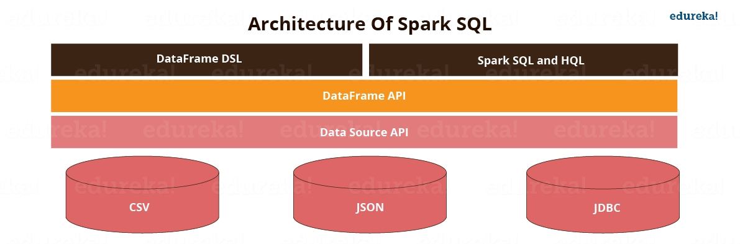

***How does Spark SQL work?***

**Spark SQL blurs the line between RDD and relational table**. It offers much tighter integration between relational and procedural processing, through declarative ***DataFrame APIs*** which integrates with Spark code. It also provides higher optimization. ***DataFrame API*** and ***Datasets API*** are the ways to interact with Spark SQL. With ***Spark SQL***, ***Apache Spark*** is accessible to more users and improves optimization for the current ones. ***Spark SQL*** provides ***DataFrame APIs*** which perform relational operations on both external data sources and Spark’s built-in distributed collections. It introduces an extensible optimizer called Catalyst as it helps in supporting a wide range of data sources and algorithms in Big Data.

Spark runs on both Windows and UNIX-like systems (e.g. Linux, Microsoft, Mac OS). It is easy to run locally on one machine — all you need is to have java installed on your system PATH, or the JAVA_HOME environment variable pointing to a Java installation.

Read more [here](https://www.edureka.co/blog/spark-sql-tutorial/).

### **2.3. Spark Streaming**

***Spark Streaming*** is a lightweight API that allows developers to perform ***batch processing*** and ***real-time streaming*** of data with ease.

***Spark Streaming*** is an extension of the core ***Spark API*** that enables ***scalable***, ***high-throughput***, ***fault-tolerant*** stream processing of live data streams.

***Spark streaming*** *provide:*

* Secure.
* Reliable
* Fast processing

for live data streams.

*Example:*

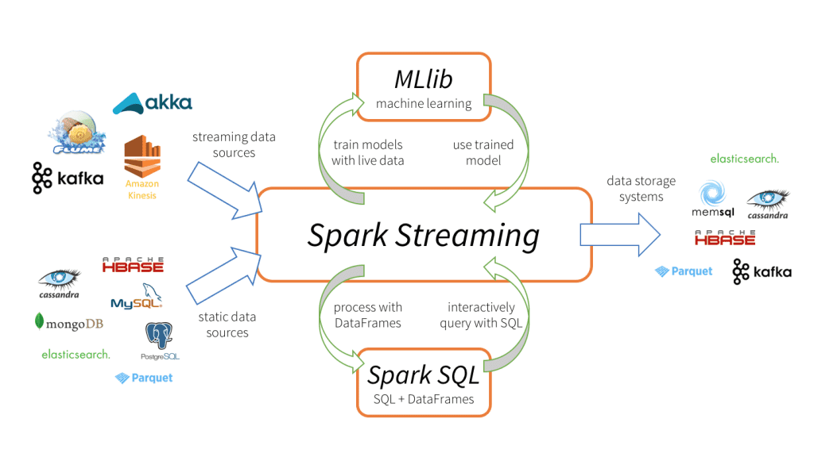

***How Spark Streaming work:***

Data can be ingested from many sources like ***Kafka***, ***Kinesis***, or ***TCP*** ***sockets***, and can be processed using complex algorithms expressed with high-level functions like *map*, *reduce*, *join* and *window*.

Finally, processed data can be pushed out to filesystems, databases, and live dashboards. In fact, you can apply ***Spark’s machine learning*** and ***graph processing algorithms*** on data streams.

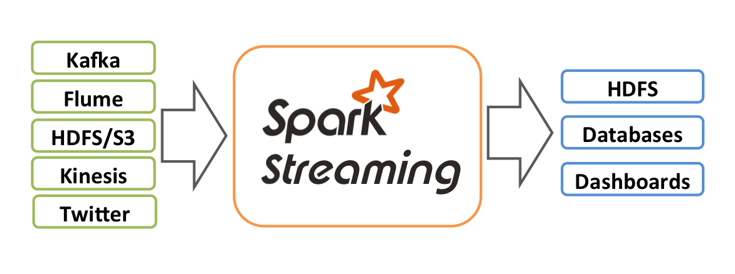

Internally, it works as follows. ***Spark Streaming*** receives live input data streams and divides the data into batches, which are then processed by the ***Spark engine*** to generate the final stream of results in batches.

*Four major aspects of* ***Spark Streaming****:*

* Fast recovery from failures and stragglers.
* Better load balancing and resource usage.
* Combining of streaming data with static datasets and interactive queries.
* Native integration with advanced processing libraries (SQL, machine learning, graph processing)

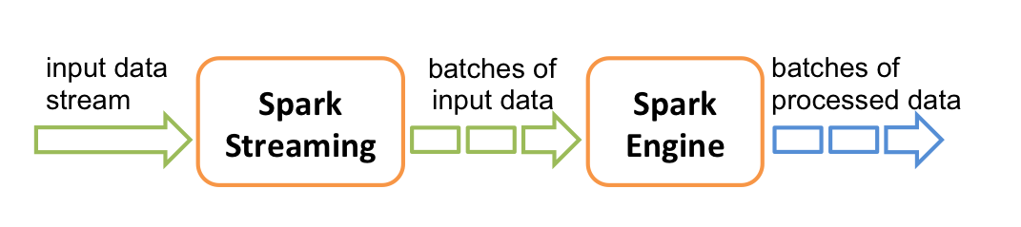

### **2.4. MLlib**

***Spark MLlib*** is a low-level machine learning library that is simple to use is scalable and compatible with various programming languages.

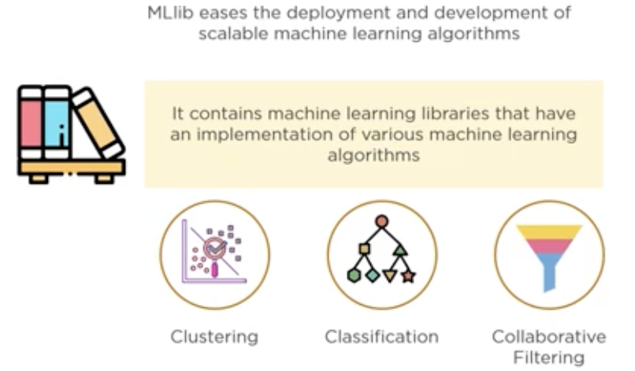

### **2.5. GraphX**

***GraphX*** is Spark’s own ***Graph Computation Engine*** and data store.

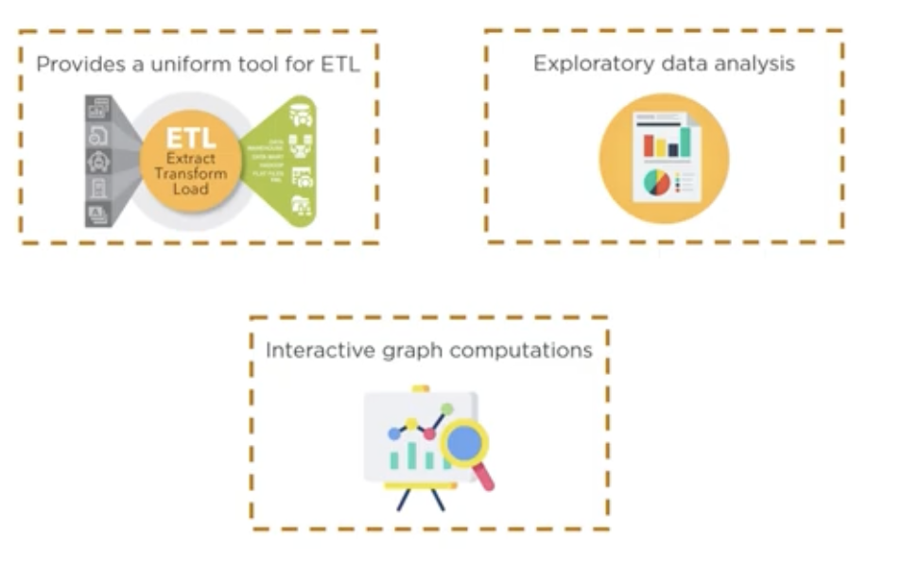

### **2.6. Cluster Manager**

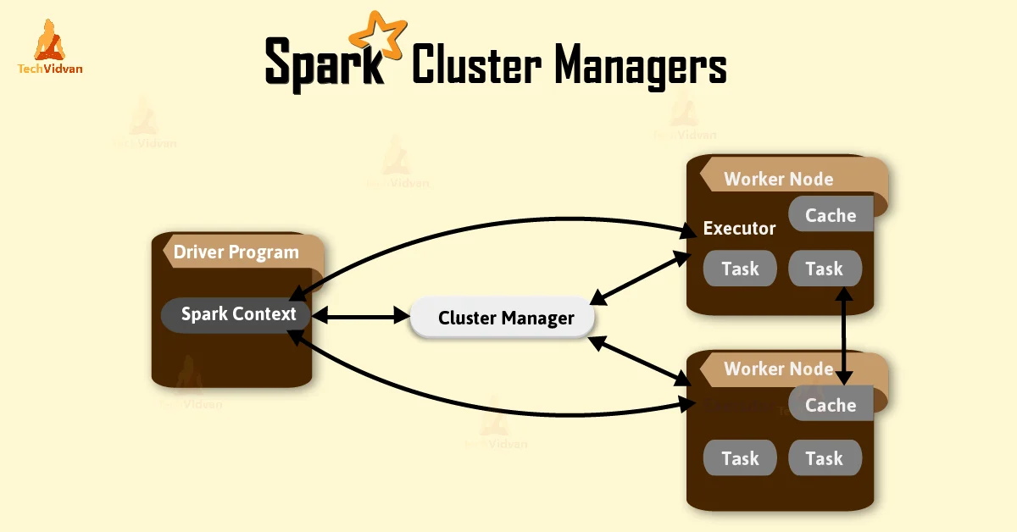

***Cluster manager*** is a platform (cluster mode) where we can run ***Spark***. Simply put, cluster manager provides resources to all worker nodes as per need, it operates all nodes accordingly.

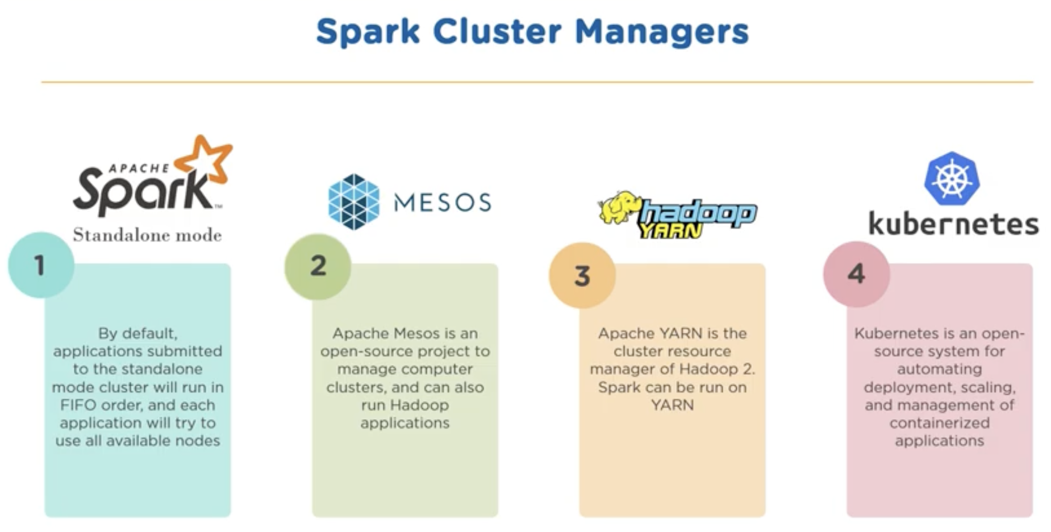

### **2.7. SparkContext**

The ***SparkContext*** can connect to several types of ***cluster managers*** (*either Spark’s own standalone cluster manager, Mesos, YARN or Kubernetes*), which allocate resources across applications. Once connected, Spark acquires executors on nodes in the cluster, which are processes that run computations and store data for your application. Next, it sends your application code (defined by JAR or Python files passed to SparkContext) to the executors. Finally, SparkContext sends tasks to the executors to run.

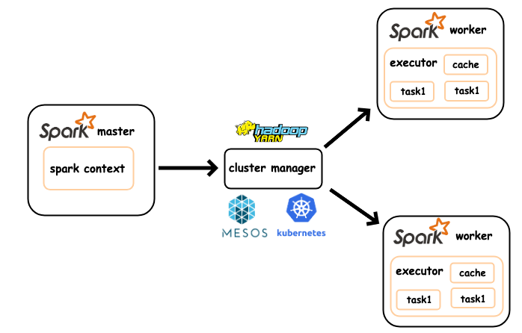

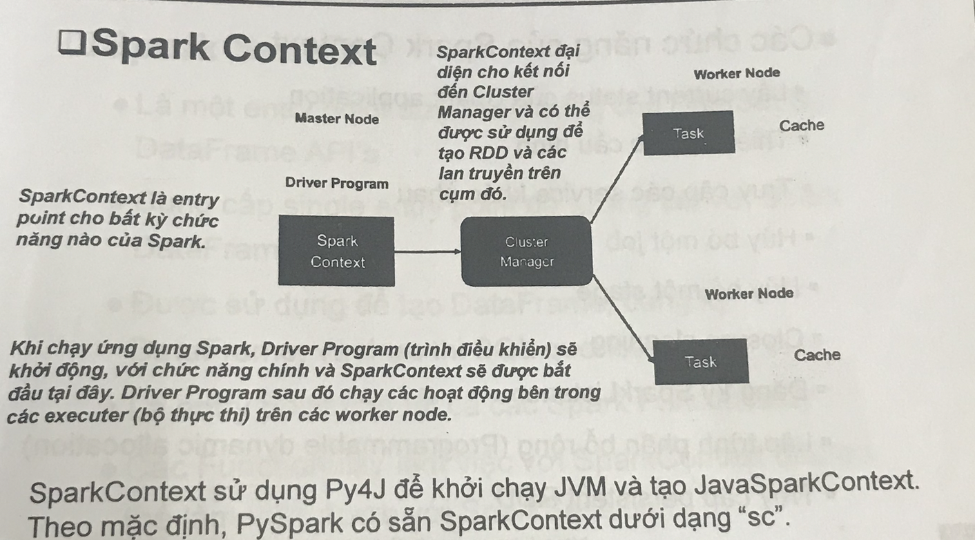

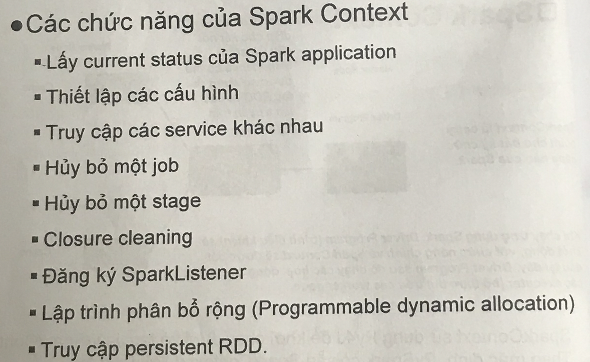

### **2.8. SparkSession**

As we know, in previous versions, spark context is the entry point for spark, As ***RDD*** was the main API, it was created and manipulated using context API’s. For every other API, we needed to use a different context.

For streaming we needed ***streamingContext.*** For ***SQL sqlContext*** and for ***hive hiveContext.***But as dataSet and DataFrame API’s are becoming new standalone API’s we need an entry-point build for them. So, in spark 2.0, **we have a new entry point build for DataSet and DataFrame API’s called as *Spark-Session.***

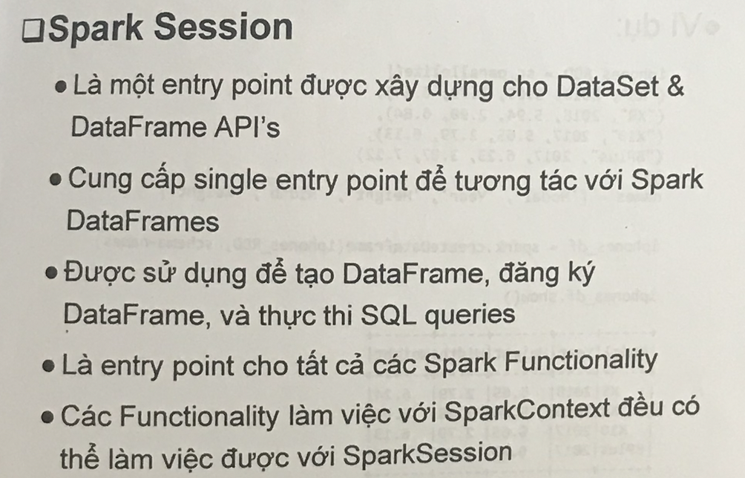

## **3. PySpark – RDDs**

### **3.1. RDDs**

***RDDs*** are the main logical data units in ***Spark***. They are a distributed collection of objects, which are stored in memory or on disks of different machines of a cluster. **A single *RDD* can be divided into multiple logical partitions so that these partitions can be stored and processed on different machines of a cluster. *RDDs*** are immutable (read-only) in nature. You cannot change an original ***RDD***, but you can create new RDDs by performing coarse-grain operations, like transformations, on an existing RDD.

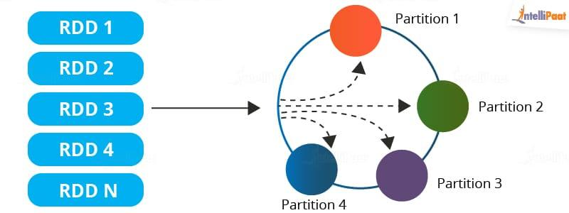

An ***RDD*** in ***Spark*** can be cached and used again for future transformations, which is a huge benefit for users. ***RDDs*** are said to be lazily evaluated, i.e., they delay the evaluation until it is really needed. This saves a lot of time and improves efficiency.

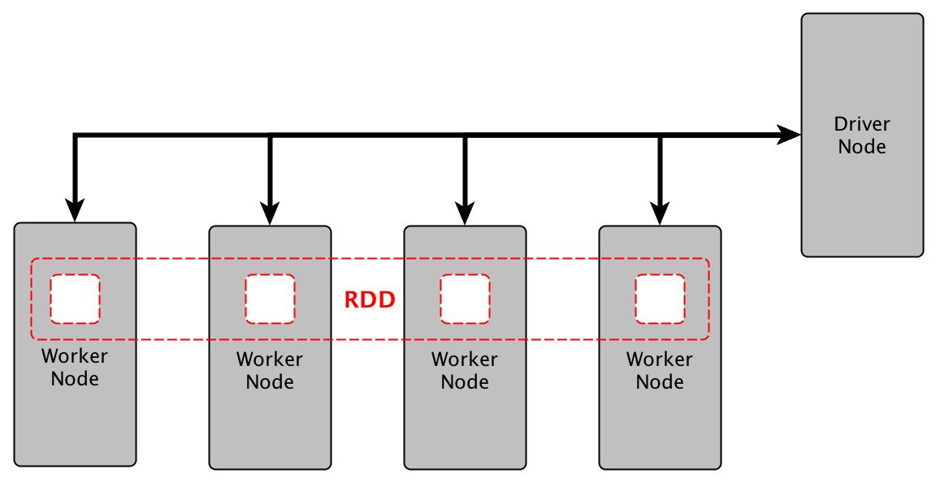

### **3.2. Spark RDD Operations**

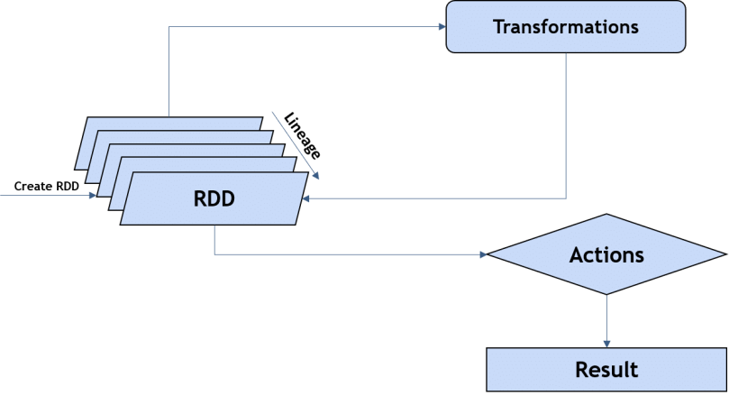

### **3.2.1. Transformations**

These are functions that accept the existing ***RDDs*** as input and output one or more ***RDDs***. However, the data in the existing ***RDD*** in Spark does not change as it is immutable. Some of the transformation operations are provided in the table below:

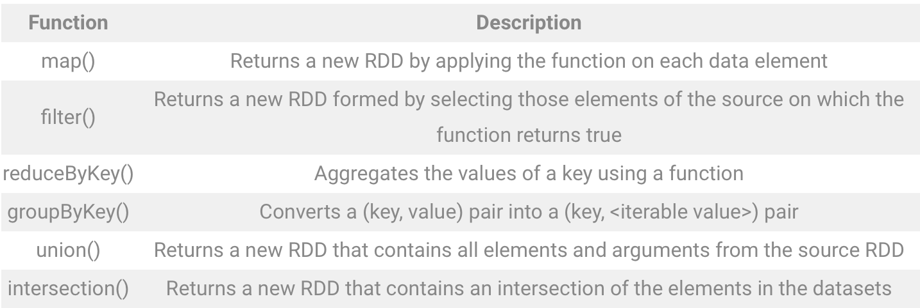

#### 3.2.1.1. Narrow Transformation

### **3.2.2. Actions**

Actions in ***Spark*** are functions that return the end result of ***RDD*** computations. It uses a lineage graph to load data onto the ***RDD*** in a particular order. After all of the transformations are done, actions return the final result to the ***Spark Driver***. Actions are operations that provide ***non-RDD values.*** Some of the common actions used in Spark are given below:

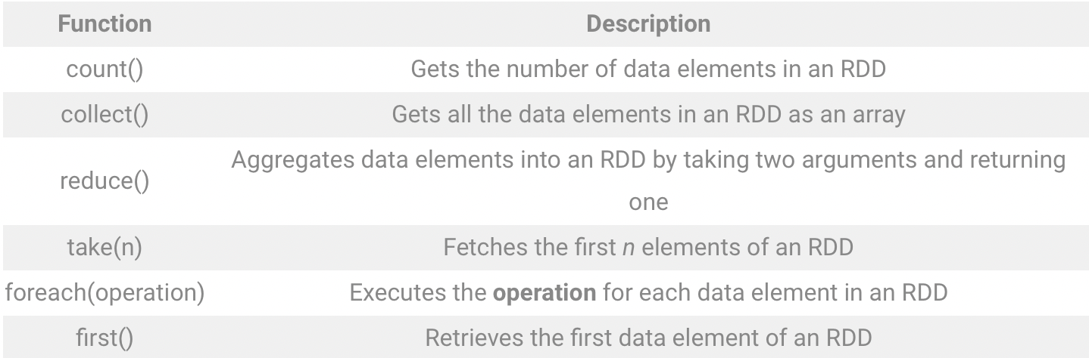

## **4. Structure Streaming in PySpark**

1. Starting with the ***Spark Streaming Context (SSC)***, the ***Spark Driver*** will execute long-running tasks on the ***executors*** (***Spark Workers***).
2. When start the computation (*in your code is* ***ssc.start()***). The ***Receiver*** on the ***executors*** (*Executor 1 in this diagram*) receives a data stream from the ***Streaming Sources***. ***Spark Streaming*** can receive ***Kafka*** or ***Twitter***, and/or you can build your own custom receiver. With the incoming data stream, the ***receiver*** divides the stream into blocks and keeps these blocks in memory (*Block Mgmt*).
3. These data blocks are replicated to another executor for high availability.
4. The block ID information is transmitted to the block manager master on the driver, thus ensuring that each block of data in memory is tracked and accounted for.
5. For every *batch interval* configured within ***SSC*** (*commonly, this is every1 second*), the driver will launch ***Spark*** tasks to process the blocks. Those blocks are then persisted to any number of target data stores, including cloud storage (*for example, S3, WASB*), relational data stores (*for example, MySQL, PostgreSQL, and so on*), and *NoSQL* stores.

### **4.2. Discretized Stream (Dstream)**

***Discretized Stream*** or ***DStream*** is the basic abstraction provided by ***Spark Streaming***. It represents a continuous stream of data, either the input data stream received from source, or the processed data stream generated by transforming the input stream.

Each ***RDD*** in a ***DStream*** contains data from a certain interval, as shown in the following figure.

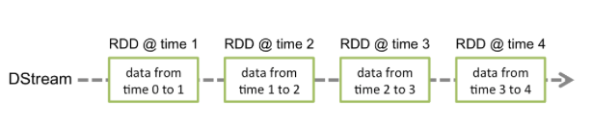

Any operation applied on a ***DStream*** translates to operations on the underlying ***RDDs.***

*For example:*

in the earlier example of **converting a stream of lines to words**, the ***flatMap*** operation is applied on each ***RDD*** in the lines ***DStream*** to generate the ***RDDs*** of the words ***DStream***. This is shown in the following figure.

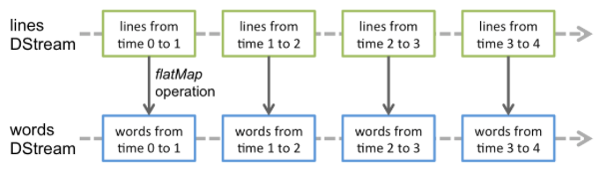

*For example (other example for more detail):*

the lines of ***DStream*** is ***micro-batched*** into seconds where each square represents a ***micro-batch*** of events that occurred within that second window:

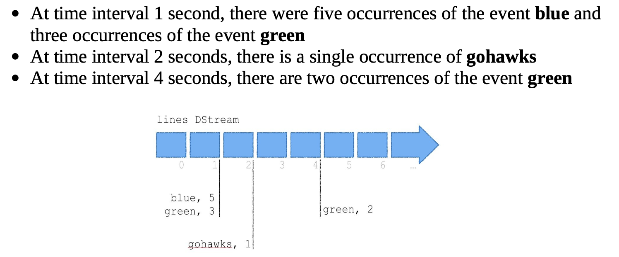

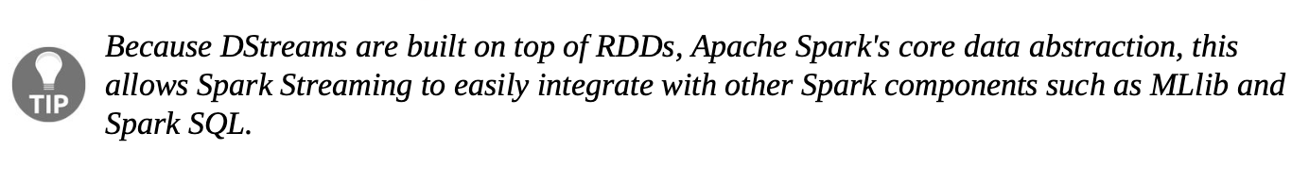

HW: have 1M rows filter → how does it work ? Spark and SQL

df = pd.read_csv()

df = pyspark.read()

df.show()